In caAERS, you can import XML files to minimize the amount of data entry that you need to perform, and you can export caAERS data to XML files so that it may be imported to another version of caAERS.
- For information about importing XML files into caAERS, see Importing XML Files.
- For more information about exporting XML files from caAERS, see Exporting from caAERS.

Importing XML Files
If you have previously used other applications and databases to maintain studies/protocols, subjects/participants, investigators, research staff, and organizations, you can import the data via an XML file instead of manually entering it. You must create separate XML files for each data type, e.g., Study file, Subject file, etc. Combining everything into a single XML file will cause the import to fail. If the file format you try to import does not mach the allowed format, the import will fail. To review copies of the XSD files and sample XML files, go to https://ncisvn.nci.nih.gov/svn/caaersappdev/branches/releases/caaers/1.9.2-stable/core/src/main/resources/schema/integration .
The following table lists where in the guide to refer to when importing different files.
Import | How to...
Investigators | Importing XML Files
MedDRA File | Importing a MedDRA File
Organizations | Importing XML Files
Report Definitions | Importing a Report Definition
Research Staff | Importing XML Files
Rules | Importing a Rule Set
Study | Importing XML Files
Subject | Importing XML Files
To import an XML file
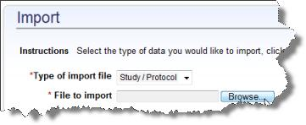
Note: To import a MedDRA terms file, see Importing a MedDRA File.
- Create an XML file containing the information you want to import.
- Click the Administration tab.
- Click Import in the task menu.
- Select the data that you want to import:
  - Study/Protocol
  - Subject
  - Investigators
  - Research Staff
  - Organizations
- Click Browse to locate and select the XML file that contains the information.
- Click Continue. The Review and Submit page opens.
- The system validates the XML file and show a synopsis of what will be imported.
  - If the file is invalid, there will be a description of the problem. Click Back to select another file or fix the file.
- If the information looks correct, click Import. This may take minutes to hours to complete.
- The Import Summary page opens.

Importing a MedDRA File
The caAERS installation includes the CTC v2 (Common Terminology Criteria) and CTCAE v3 (Common Terminology Criteria for Adverse Events) vocabulary. CTC is a free open-source medical vocabulary that can be used to code clinical studies. An alternative to CTC is MedDRA terminology. MedDRA is the Medical Dictionary for Regulatory Activities. This terminology is used to classify adverse event information associated with the use of biopharmaceuticals and other medical products. If your organization has a license to use MedDRA, the vocabulary can be imported into caAERS.
To import MedDRA files
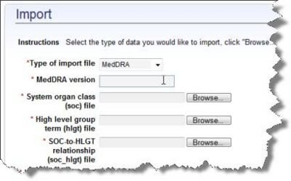
- Locate the folder where MedDRA is stored.
  - Note: The MedDRA files and folder must be located on the server that caAERS is installed on. You cannot import files from a folder that is located on the "client side" or desktop computer.
- Enter the name of the MedDRA version to be imported. This will be displayed in caAERS after import.
- For each of the following ascii files, click Browse to select the file location.
  - System organ class (soc) file
  - High level group term (hlgt) file
  - SOC-to-HLGT relationship (soc_hlgt) file
  - High level term (hlt) file
  - HLGT-to-HLT relationship (hlgt_hlt) file
  - Preferred term (pt) file
  - HLT-to-PT relationship (hlt_pt) file
- Once all the file locations are specified, click Import. You will see screen confirmation of the import process.
- The system validates the XML file and shows a synopsis of what will be imported. </span>
  - If the file is invalid, there will be a description of the problem. Click Back to select another file or fix the file.
- If the information looks correct, click Import. This may take minutes to hours to complete.
- The Import Summary page opens.

Exporting from caAERS
The following table lists where in the guide to refer to export different files.
Export | How to...
Study | Exporting a Study
Subject
Investigators
Research Staff
Investigational New Drugs | Searching for and Exporting INDs
Organizations
Rules | Exporting Rules
Report Definitions | Exporting a User-Defined Adverse Event Report  IMPORTANT: If you are upgrading, you must first export your user-defined rules to an XML file (If you do not export your Rules to an XML before upgrading, those rules will be lost.) Once the upgrade is complete, then you can import the rules XML file back into caBIG caAERS.
Adverse Event Reports | - From the Adverse Events, Managing Reports option  - From the Adverse Events, Enter AEs, Review and Submit page

